Assignment 3 : Bootstrap

**Name: Ida Bagus Ketut Yoghantara**

**Lab Scenario 1**

You have been tasked with creating a page to display the details of a record album. You will build this page up over the course of the next several labs. The starting page only needs to target medium and large devices; support for smaller devices will be added later.

These are the necessary components:

1. A banner to display the name of the music store, Music Store
2. Album information
3. An image on the left side to represent the cover art. The image is provided here.
4. The basic information on the album on the right side.

Finally, you have been requested to implement a new theme that is different from the default.

You are free to choose whatever theme you like, and are free to determine the sizing that you believe will work best for the page.

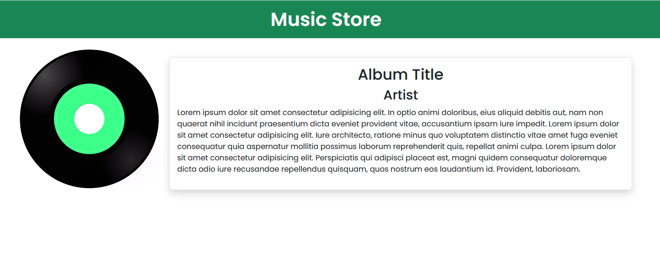

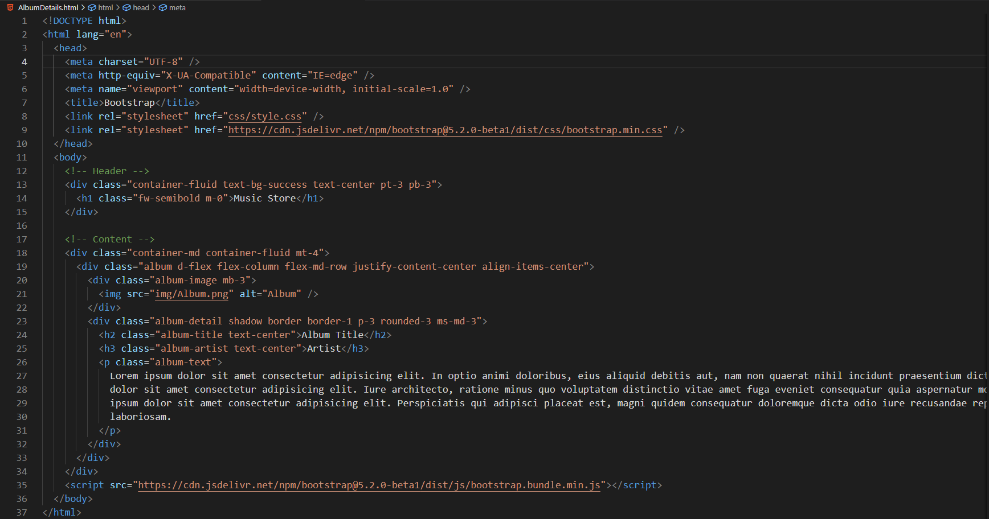

**Zip Folder**



**Lab Scenario 2:**

You have been tasked with creating a page to allow people to submit new albums to the site. You will build this page over separate labs. The requirements for the page right now are as follows:

1. A banner with the text "Submit Album"
2. A collapsable region with the following sections:
3. Album Title and Artist
4. Track Information
5. Expert Review

Place lorem ipsum text into the sections as placeholders.

You can use lipsum.com to generate lorem ipsum.

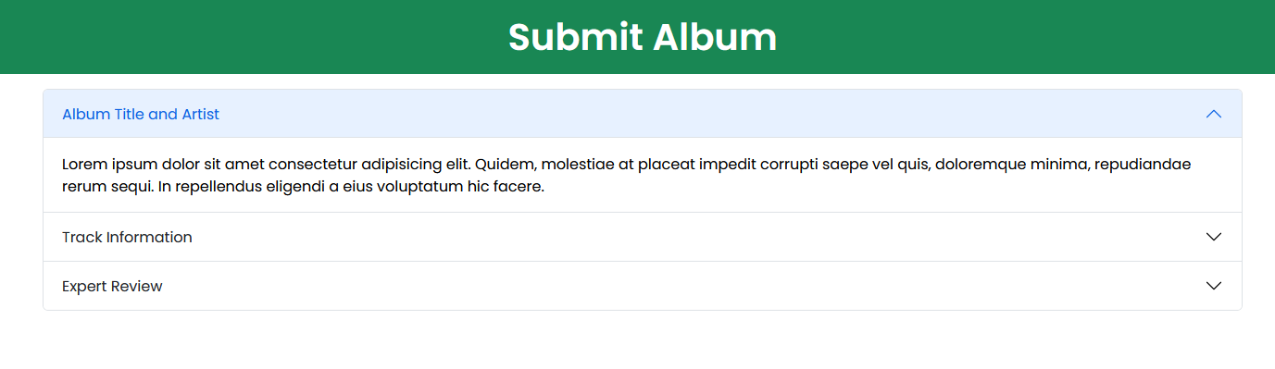

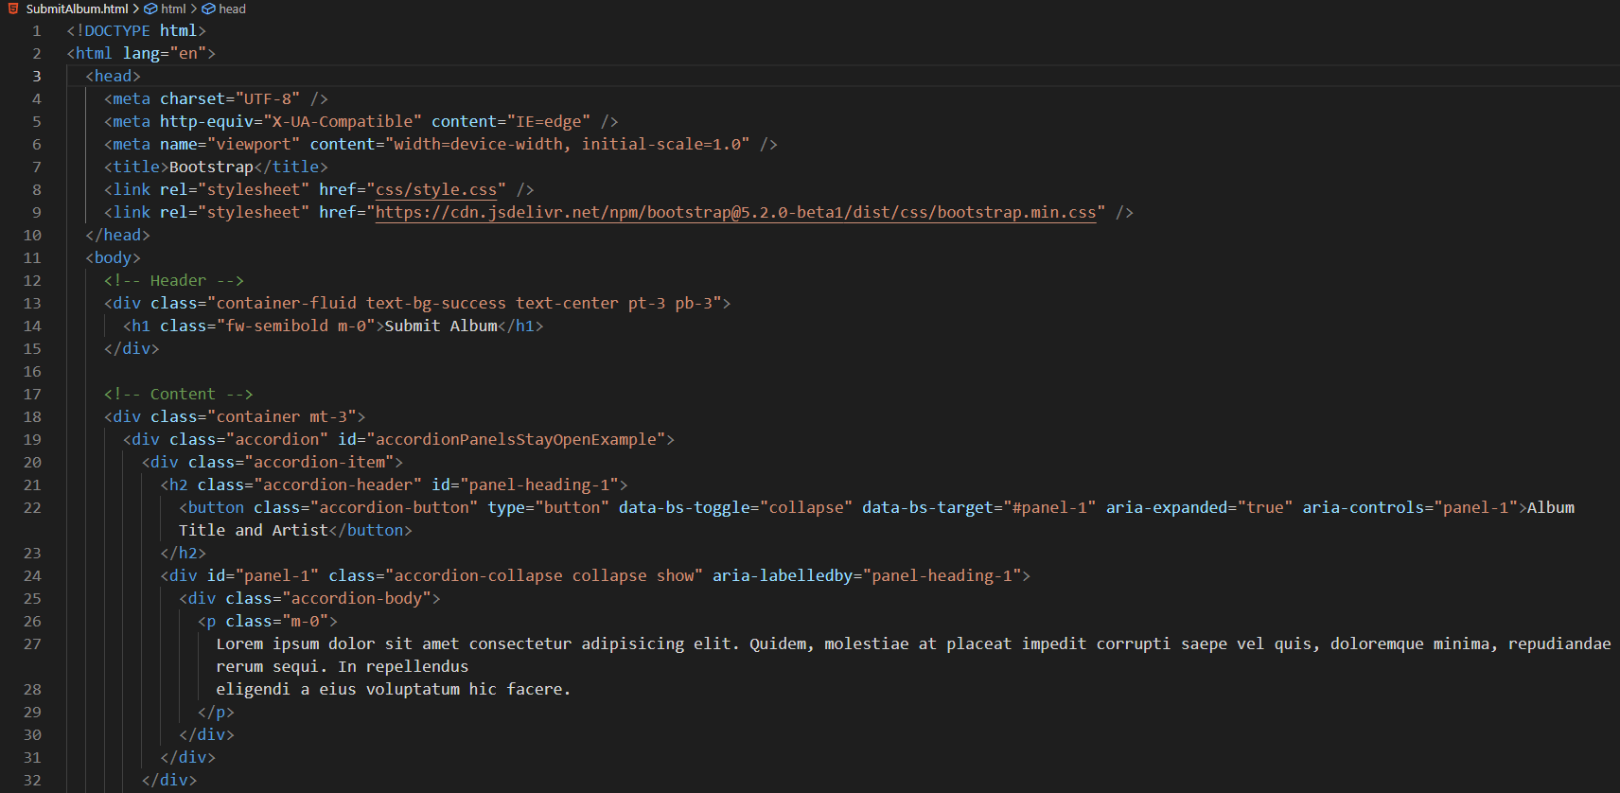

**Lab Scenario 3:**

You have been tasked with creating a page with a modal dialog box. To complete the lab, complete the following steps:

1. Create a page named Confirm.html
2. Add the required references for Bootstrap, including the CSS and JavaScript files.
3. Add the markup for a modal dialog box. The dialog box should contain the following information:
   1. A header with the text Are you sure?, along with an X that will close the dialog box.
   2. A body with the text Are you sure you wish to submit this album?
   3. A footer with two buttons, one labeled Cancel, and the other labeled Confirm.
4. Add the markup to the Cancel button pictured in the wireframe to close the dialog box. The Confirm button does not need to do anything.
5. Add a button to the page with the text Open dialog. Configure the button to open the modal dialog box.
6. The color scheme of the modal dialog box does not matter.

